Week 5 Technical Report
Sentiment Analysis on Tourist Reviews: Methods, Honest Evaluation and Strategic Insights
Student: Akshita | B.Tech Computer Science & Engineering, Amritsar Group of Colleges
Programme: Yuva Internship, Tourism Data Science & Analytics | Resubmission date: 06 November 2026
Code, data and figures: https://github.com/avy-pixel/Tourism-insights (folder Week 5 - Sentiment Analysis)

1. Executive Summary
This report classifies 2,500 tourist reviews of 12 Indian destinations as Positive, Neutral or Negative, compares rule-based and machine-learning sentiment methods, and turns the results into destination-level actions. The review corpus is simulated (generated by a seeded, template-based script; see Section 3), so absolute accuracy figures describe how well the methods separate this synthetic text, not how they would perform on real TripAdvisor or Google reviews. Every number below is computed by scripts in the repository and saved to metrics_v2/.
- Sentiment mix: 56.4% Positive (1410), 19.6% Neutral (490), 24.0% Negative (600). Overall Net Sentiment Score (NSS = %Positive − %Negative) is +32.4.
- Rule-based vs supervised: VADER reaches 73.0% accuracy (macro-F1 57.2%) and TextBlob 69.3% (macro-F1 61.6%). TF-IDF classifiers reach 96.1–96.5% accuracy under text-grouped 5-fold cross-validation. The blended ensemble scores 96.5% accuracy (95% CI 95.4–97.5), macro-F1 96.2%, Cohen's κ 0.942. The four supervised models are statistically indistinguishable (overlapping confidence intervals).
- Where models fail: all 87 ensemble errors are Positive↔Neutral confusions inside mixed-clause sentences ("praise, though complaint"). On those 659 sentences the ensemble scores 86.8% and VADER only 17.1%; VADER recalls just 7.1% of Neutral reviews.
- Aspect and destination findings: aspect-level NSS ranges only from +26.9 (Accessibility) to +39.6 (Hospitality), and the difference is not statistically significant (χ² p = 0.26). Destination differences are larger: Golden Temple, Amritsar leads (+48.0) while IGI Airport Terminal 3 trails (+21.6); their 95% intervals do not overlap.
- Strategic implication: prioritise the lowest-scoring destinations (two of the three lowest are airport terminals), use mixed-clause and Neutral feedback as an early-warning signal, and replace rule-based scoring with a locally trained classifier validated on real reviews before any policy decision (Section 9).

2. Problem Formulation
Star ratings summarise satisfaction but not its cause. A three-star rating can mean a long queue, an unclean washroom, or a high ticket price. Text analytics can recover the cause at scale. The objectives of this report are:
- Classify each review as Positive, Neutral or Negative and compare lexicon-based and supervised methods on identical data.
- Evaluate the models in a way that avoids inflated scores (grouped splits, confidence intervals, error analysis).
- Measure sentiment by aspect, destination, tourist segment and quarter, and test whether differences are statistically meaningful.
- Convert the evidence into specific, measurable actions for tourism management, with explicit limitations.

3. Data: Source, Construction and Limitations

3.1 How the corpus was built
No public review dataset was used. The task allows a simulated dataset, and the corpus was generated by scripts/prepare_reviews_data.py (random seed 42). The script draws a destination (12 sites in four categories), an experience aspect (six aspects), a tourist segment and a date between 2023Q1 and 2024Q4. It then assembles review text from sentiment-specific templates and vocabulary lists, with about 12% deliberately mixed-tone sentences ("…was sublime, though a bit crowded…"). Star ratings are drawn per class (Positive: 4–5, Neutral: 3, Negative: 1–2) and the sentiment label is derived from the rating.
Attribute | Type | Content
review_id | string | 2,500 unique IDs (REV-0001 to REV-2500)
destination / category / state | string | 12 destinations in 4 categories: Heritage (4), Spiritual (3), Nature & Leisure (3), Transit (2)
tourist_segment / origin_type | string | 6 segments (Domestic Family/Group/Solo, International Europe/USA/Asia-Pacific); 1,710 domestic, 790 international
review_date / travel_quarter | date / string | 2023-01 to 2024-12; 8 quarters
rating | int | 1–5 stars
ground_truth_sentiment | string | Negative (1–2), Neutral (3), Positive (4–5)
primary_aspect | string | Cleanliness, Hospitality, Value for Money, Accessibility, Heritage/Culture, Crowd Management
raw_text / cleaned_text | string | Original review; lemmatised, negation-tagged NLP string

3.2 Properties that limit what the results can claim
- Low text diversity: 2,500 rows contain only 1,244 distinct review texts. Some sentences repeat dozens of times.
- Label noise by construction: 39 texts appear under more than one label (the same template can be assigned rating 3 or 4), so a perfect score is impossible and part of the residual error is irreducible.
- Templated wording: some sentences are semantically odd (for example "historical architecture at an airport terminal"). Sentiment words are strongly tied to the label, which makes classification easier than on natural text.
- Consequence: accuracy near 96% should be read as "the methods can recover the generator's sentiment signal", not as an expected real-world result. Section 7 shows that the score does not come from exact-duplicate leakage, and Section 10 lists the remaining threats to validity.

4. NLP Preprocessing Pipeline
Implemented in preprocess_text() (scripts/prepare_reviews_data.py) with NLTK. The six stages and the reason for each:
# | Stage | What it does | Why
1 | Contraction expansion | Expands 46 contractions ("didn't" → "did not") | Exposes negation words before punctuation is stripped
2 | Noise filtering and normalisation | Lower-cases; removes HTML, URLs, digits and symbols | Reduces vocabulary size without losing sentiment words
3 | Tokenisation | NLTK word_tokenize | Splits text into tokens for tagging and lemmatisation
4 | Negation tagging | Prefixes the token after not/no/never/without/barely… with NOT_ | Lets "not care" be a different feature from "care"
5 | Stop-word filtering | Removes NLTK stop-words and tokens under 3 letters, keeps negation words | Removes high-frequency words with no polarity
6 | POS-guided lemmatisation | WordNet lemmatiser using each token's part-of-speech tag | "ruined/ruins" → "ruin"; merges inflected forms

def preprocess_text(text):
t = expand_contractions(text.lower())
t = re.sub(r'<.*?>', ' ', t); t = re.sub(r'http\S+|www\S+', ' ', t)
t = re.sub(r'[^a-zA-Z\s]', ' ', t); t = re.sub(r'\s+', ' ', t).strip()
tokens = word_tokenize(t)
neg, out = False, [] # stage 4: tag the token after a negator
for tok in tokens:
if tok in negation_words: neg = True; out.append(tok)
elif neg: out.append("NOT_" + tok); neg = False
else: out.append(tok)
tags = nltk.pos_tag([w.replace("NOT_", "") for w in out])
lemmas = []
for orig, (w, pos) in zip(out, tags): # stages 5-6
if w not in custom_stopwords and len(w) > 2:
lemma = lemmatizer.lemmatize(w, get_wordnet_pos(pos))
lemmas.append("not_" + lemma if orig.startswith("NOT_") else lemma)
return " ".join(lemmas)

4.1 Three fully worked examples
Each example is scored by a model trained without that exact review text, so the probabilities are genuine held-out predictions. The examples were chosen to show (1) negation tagging working, (2) negation tagging failing, and (3) a mixed-clause review where VADER is wrong.
Stage | Example 1: negation kept | Example 2: negation lost | Example 3: mixed clause
Review / destination | REV-0059  Goa Beaches (Calangute & Baga) | REV-0002  Alleppey Backwaters & Houseboats | REV-0001  Varanasi Ghats & Kashi Vishwanath
Rating → true label | 1 stars → Negative | 4 stars → Positive | 3 stars → Neutral
Raw text | Poor preservation of historic heritage. Centuries-old sandstone walls are defaced with graffiti and authorities do not care. Truly an unacceptable experience that demands immediate government intervention. | Very reasonable entry pricing and affordable cafeteria options. A truly splendid heritage experience without any financial exploitation. We would eagerly recommend Alleppey Backwaters & Houseboats to every traveler! | The heritage value of Varanasi Ghats & Kashi Vishwanath is significant, but standard amenities are just passable and weather was humid.
After stages 1–2 (expanded, cleaned) | poor preservation of historic heritage centuries old sandstone walls are defaced with graffiti and authorities do not care truly an unacceptable experience that demands immediate government intervention | very reasonable entry pricing and affordable cafeteria options a truly splendid heritage experience without any financial exploitation we would eagerly recommend alleppey backwaters houseboats to every traveler | the heritage value of varanasi ghats kashi vishwanath is significant but standard amenities are just passable and weather was humid
Final lemma string (stages 3–6) | poor preservation historic heritage century old sandstone wall deface graffiti authority not not_care truly unacceptable experience demand immediate government intervention | reasonable entry pricing affordable cafeteria option truly splendid heritage experience without financial exploitation would eagerly recommend alleppey backwater houseboats every traveler | heritage value varanasi ghat kashi vishwanath significant standard amenity passable weather humid
VADER compound → label | -0.879  (pos 0, neu 0.664, neg 0.336) → Negative | 0.902  (pos 0.355, neu 0.645, neg 0) → Positive | 0.273  (pos 0.147, neu 0.853, neg 0) → Positive
TextBlob polarity | -0.200 | 0.364 | 0.188
LR probabilities (N | Neu | P) | N 0.986 | N 0.005 | P 0.008 | N 0.012 | N 0.008 | P 0.980 | N 0.016 | N 0.957 | P 0.027
SVM probabilities | N 0.982 | N 0.005 | P 0.013 | N 0.002 | N 0.004 | P 0.994 | N 0.003 | N 0.973 | P 0.024
NB probabilities | N 1.000 | N 0.000 | P 0.000 | N 0.000 | N 0.000 | P 1.000 | N 0.000 | N 1.000 | P 0.000
Ensemble = .45·LR + .35·SVM + .20·NB | N 0.988 | N 0.004 | P 0.008 | N 0.006 | N 0.005 | P 0.989 | N 0.008 | N 0.971 | P 0.021
Ensemble prediction | Negative ✓ | Positive ✓ | Neutral ✓

Reading the examples. In Example 1, "do not care" becomes the extra feature not_care, and both VADER and the ensemble correctly return Negative. In Example 2, "without any financial exploitation" should be a positive statement; the negation tag attaches to the next token, "any", which is a stop-word and is deleted in stage 5, so the tag is lost and without financial exploitation remains. The review is still classified correctly because the surrounding vocabulary ("splendid", "recommend") is strongly positive, but the pipeline would mishandle a review that depended on that negation. This is a known limitation (Section 10) and a concrete improvement target: tag the next content word after the stop-word filter. Example 3 is the typical failure of lexicon tools: "significant" pushes VADER to +0.273 (Positive) while the true label is Neutral; the supervised ensemble learns that "standard amenity … passable" marks Neutral and returns P(Neutral) = 0.971.

5. Sentiment Methods and Rationale
Method | How it works | Why it is included
VADER (NLTK) | Sums valence scores of lexicon words with rules for negation, intensifiers and punctuation; compound c = x / √(x² + 15). Positive if c ≥ 0.05, Negative if c ≤ −0.05, else Neutral. | Standard zero-training baseline for short social/review text
TextBlob | Averages word polarity from the Pattern lexicon. Positive if > 0.10, Negative if < −0.05, else Neutral. | Second lexicon baseline with a different lexicon
TF-IDF + Multinomial NB | Predicts argmax of ln P(c) + Σ xᵢ ln[(N_ci + α)/(N_c + αV)], α = 0.5 | Fast, strong on small text corpora
TF-IDF + Logistic Regression | Softmax over linear scores with L2 penalty (C = 2.0, class-balanced weights) | Interpretable: coefficients show which terms drive each class
TF-IDF + Linear SVM | Max-margin linear classifier, C = 1.0, Platt-calibrated (5-fold) to give probabilities | Often the strongest linear text model
Blended ensemble | P = 0.45·P_LR + 0.35·P_SVM + 0.20·P_NB, argmax | Combines three views; weights were set a priori, not tuned (see 7.2)

Features. TF-IDF with sublinear term frequency, tf-idf = (1 + ln tf) × (ln[(1 + N)/(1 + df)] + 1), unigrams and bigrams, min_df = 2, vocabulary capped at 2,500 terms. The vectoriser is fitted on training folds only inside every cross-validation split.
Why not a transformer? Models such as BERT or RoBERTa would be the natural choice for real reviews. They were not used here because (a) the corpus has only 1,244 distinct sentences, so a large pretrained model would add cost without testable benefit, (b) linear TF-IDF models give interpretable coefficients (Figure 3) that suit a management audience, and (c) the task specifies NLTK/spaCy-style classical pipelines. A transformer comparison on real reviews is listed as future work.

6. Evaluation Protocol
The previous version of this project used a single random 80/20 split on a corpus where most sentences repeat. This version uses protocols that prevent the same sentence appearing on both sides of a split.
- Text-grouped 5-fold cross-validation (StratifiedGroupKFold, seed 42): all reviews with identical raw_text stay in the same fold, and class proportions are preserved. Predictions from the five held-out folds are pooled into one out-of-fold prediction for each of the 2,500 reviews.
- Leave-destinations-out (GroupKFold, 4 folds of 3 destinations): the model is tested on destinations it has never seen.
- 95% confidence intervals from 1,000 bootstrap resamples of the 1,244 unique texts (a cluster bootstrap, so repeated sentences do not make the intervals look narrower than they are).
- Original random split is also reported, only to quantify how much leakage matters.
cv = StratifiedGroupKFold(n_splits=5, shuffle=True, random_state=42)
for tr, te in cv.split(df, y, groups=df.raw_text): # same text never in train+test
vec = TfidfVectorizer(ngram_range=(1,2), min_df=2,
sublinear_tf=True, max_features=2500)
Xtr = vec.fit_transform(df.cleaned_text.iloc[tr]) # fit on training fold only
Xte = vec.transform(df.cleaned_text.iloc[te])
lr = LogisticRegression(C=2.0, class_weight="balanced").fit(Xtr, y[tr])
nb = MultinomialNB(alpha=0.5).fit(Xtr, y[tr])
svm = CalibratedClassifierCV(LinearSVC(C=1.0), cv=5).fit(Xtr, y[tr])
p = (0.45*lr.predict_proba(Xte) + 0.35*svm.predict_proba(Xte)
+ 0.20*nb.predict_proba(Xte))
oof[te] = lr.classes_[p.argmax(1)] # out-of-fold prediction

7. Results

7.1 Corpus sentiment
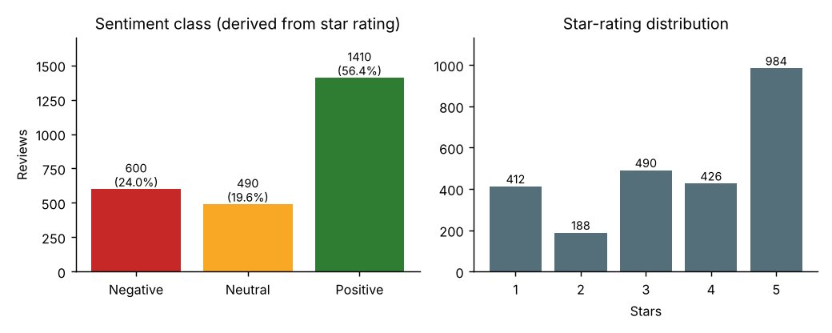
Figure 1. Sentiment class distribution and star ratings
What it shows. Positive reviews dominate (1410 of 2500, 56.4%), followed by Negative (600, 24.0%) and Neutral (490, 19.6%). The classes are imbalanced, so macro-F1 and balanced accuracy are reported alongside accuracy.
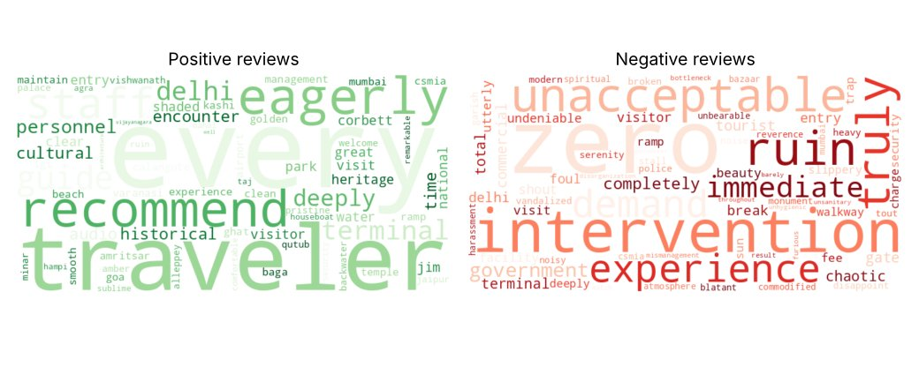
Figure 2. Word clouds of cleaned text for Positive and Negative reviews
What it shows. Positive reviews are dominated by service and recommendation vocabulary (guide, clean, recommend, eagerly, management); Negative reviews by failure vocabulary (zero, ruin, chaotic, shout, foul, intervention). Word size is term frequency in the lemmatised text.
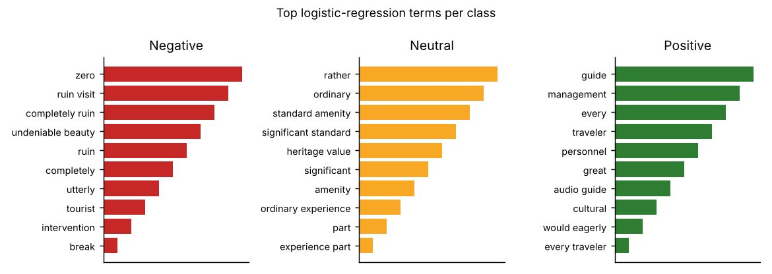
Figure 3. Highest-weighted terms per class (logistic regression)
What it shows. The terms that most increase each class probability. Negative: zero, ruin visit, completely ruin, undeniable beauty, ruin. Neutral: rather, ordinary, standard amenity, significant standard, heritage value. Positive: guide, management, every, traveler, personnel. Neutral is identified by hedging words ("rather", "standard", "though", "fair", "moderate"), which explains why mixed-tone sentences are the hard cases.

7.2 Model benchmark
Model | Accuracy % (95% CI) | Macro-F1 % | Balanced acc. % | Cohen κ | Fold acc. mean ± SD | Unseen destinations acc. %
VADER (rule-based) | 73.0 (69.2–76.2) | 57.2 | 62.2 | 0.518 | 73.0 ± 3.6 | 73.0
TextBlob (pattern-based) | 69.3 (65.1–73.3) | 61.6 | 60.1 | 0.469 | 69.3 ± 4.8 | 69.3
TF-IDF + Naive Bayes | 96.5 (95.4–97.4) | 96.2 | 97.9 | 0.941 | 96.5 ± 1.3 | 96.5
TF-IDF + Logistic Regression | 96.3 (95.1–97.4) | 96.0 | 97.4 | 0.938 | 96.3 ± 1.3 | 96.5
TF-IDF + Linear SVM | 96.1 (94.8–97.1) | 95.5 | 95.8 | 0.933 | 96.1 ± 1.4 | 96.3
Blended Ensemble (45/35/20) | 96.5 (95.4–97.5) | 96.2 | 97.5 | 0.942 | 96.5 ± 1.1 | 96.5
Table 1. Pooled out-of-fold results, text-grouped 5-fold CV (n = 2500). Last column: leave-destinations-out CV.
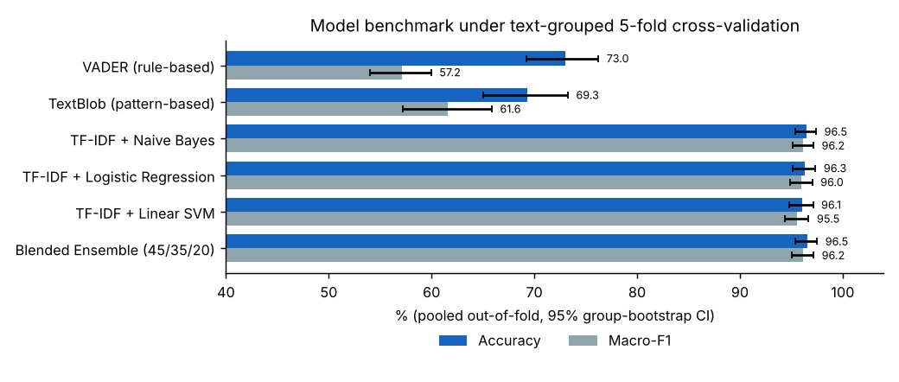
Figure 4. Accuracy and macro-F1 with 95% confidence intervals
What it shows. The four supervised models sit between 96.1% and 96.5% accuracy with heavily overlapping intervals, so none can be called better than another. All four are about 23–27 points above VADER and TextBlob, a gap far larger than the interval widths.
Three honest observations about this benchmark:
- Leakage is not what produces ~96%. With the original random split, 65.4% of test rows had their exact text in the training set and the ensemble scored 96.6%. With text-grouped folds the score is 96.5%, and on entirely unseen destinations 96.5%. The high score instead reflects the templated, label-correlated vocabulary of the simulated corpus (Section 3.2).
- The ensemble adds nothing measurable. Its accuracy equals Naive Bayes within a tenth of a point. The 45/35/20 weights were chosen a priori and not tuned; on this data a single Naive Bayes or logistic regression model is sufficient and simpler to deploy.
- Lexicon tools fail mainly on the Neutral class (next section), not on clearly positive or negative text.

7.3 Per-class performance and confusion matrices
Class (support) | Ensemble P / R / F1 % | VADER P / R / F1 % | TextBlob P / R / F1 %
Negative (600) | 100.0 / 100.0 / 100.0 | 64.7 / 91.5 / 75.8 | 81.8 / 57.5 / 67.5
Neutral (490) | 86.3 / 97.8 / 91.7 | 39.3 / 7.1 / 12.1 | 31.0 / 37.6 / 33.9
Positive (1410) | 99.2 / 94.6 / 96.8 | 79.5 / 88.1 / 83.6 | 81.1 / 85.4 / 83.2

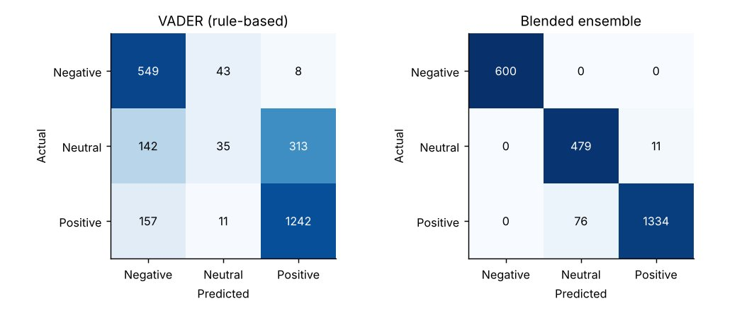
Figure 5. Pooled out-of-fold confusion matrices (rows = actual, columns = predicted)
What it shows. The ensemble never confuses Negative with another class (600 of 600 correct) and its only errors are 11 Neutral reviews predicted Positive and 76 Positive reviews predicted Neutral. VADER labels 313 of 490 Neutral reviews Positive and only 35 Neutral (recall 7.1%); it also marks 157 Positive reviews as Negative.

7.4 Error analysis
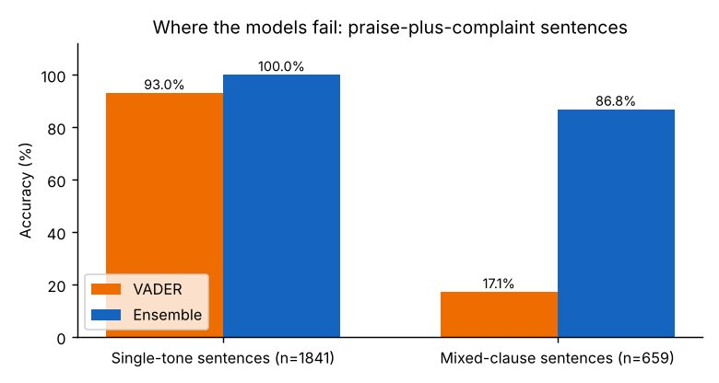
Figure 6. Accuracy on single-tone vs mixed-clause sentences
What it shows. Sentences containing "though/while/but/however/although" (659 rows) are where models fail. Ensemble accuracy drops from 100.0% on single-tone sentences (n = 1841) to 86.8% on mixed-clause ones. VADER drops from 93.0% to 17.1% because one strongly polar clause ("sublime", "significant") outweighs the hedging clause.
Negated sentences (398 rows containing not/no/never/without/zero) were classified with 100.0% accuracy by the ensemble, because in this corpus negation appears in strongly negative templates ("zero guidance", "no drinking water"). This does not show that negation is solved; real reviews contain subtler negation, as Example 2 illustrates. All 87 ensemble errors are listed in metrics_v2/ensemble_errors.csv and VADER errors in vader_errors.csv. Typical pairs:
- "The historical architecture at Taj Mahal, Agra was sublime, though weather was humid and staff seemed distracted." (true: Positive, predicted: Neutral)
- "…was sublime, though signage could be clearer and staff seemed distracted." (true: Neutral, predicted: Positive)
The same template appears under both labels (rating 3 or 4), so this residual error reflects label noise rather than a modelling defect.

7.5 Sentiment by aspect, destination, segment and time
Aspect | n | % Pos | % Neu | % Neg | NSS | 95% CI
Hospitality & Staff | 414 | 60.4 | 18.8 | 20.8 | +39.6 | 31.4 to 47.1
Value for Money | 408 | 57.8 | 21.1 | 21.1 | +36.8 | 28.7 to 44.6
Crowd Management | 400 | 54.5 | 21.5 | 24.0 | +30.5 | 22.3 to 38.7
Heritage & Cultural Experience | 451 | 56.3 | 17.7 | 25.9 | +30.4 | 22.4 to 38.1
Cleanliness & Hygiene | 437 | 56.5 | 17.2 | 26.3 | +30.2 | 22.7 to 38.2
Accessibility & Infrastructure | 390 | 52.6 | 21.8 | 25.6 | +26.9 | 18.5 to 35.1

Destination | n | % Pos | % Neu | % Neg | NSS | 95% CI
Golden Temple, Amritsar | 204 | 63.7 | 20.6 | 15.7 | +48.0 | 37.7 to 58.8
Goa Beaches (Calangute & Baga) | 197 | 63.5 | 13.2 | 23.4 | +40.1 | 28.4 to 51.8
Jim Corbett National Park | 236 | 61.0 | 16.9 | 22.0 | +39.0 | 28.4 to 48.7
Taj Mahal, Agra | 179 | 57.0 | 21.2 | 21.8 | +35.2 | 23.5 to 46.9
Varanasi Ghats & Kashi Vishwanath | 202 | 57.4 | 19.8 | 22.8 | +34.7 | 23.3 to 45.6
Amber Palace, Jaipur | 226 | 55.8 | 21.7 | 22.6 | +33.2 | 22.1 to 44.2
Hampi Ruins, Vijayanagara | 182 | 56.6 | 17.0 | 26.4 | +30.2 | 17.6 to 42.3
Rishikesh Ganges & Yoga Retreats | 216 | 51.9 | 25.5 | 22.7 | +29.2 | 19.0 to 40.3
Qutub Minar, Delhi | 207 | 53.1 | 22.2 | 24.6 | +28.5 | 17.4 to 40.1
CSMIA Terminal 2, Mumbai | 219 | 54.8 | 16.9 | 28.3 | +26.5 | 15.1 to 37.4
Alleppey Backwaters & Houseboats | 210 | 50.5 | 22.9 | 26.7 | +23.8 | 12.4 to 34.8
IGI Airport Terminal 3, Delhi | 222 | 52.3 | 17.1 | 30.6 | +21.6 | 10.4 to 32.9

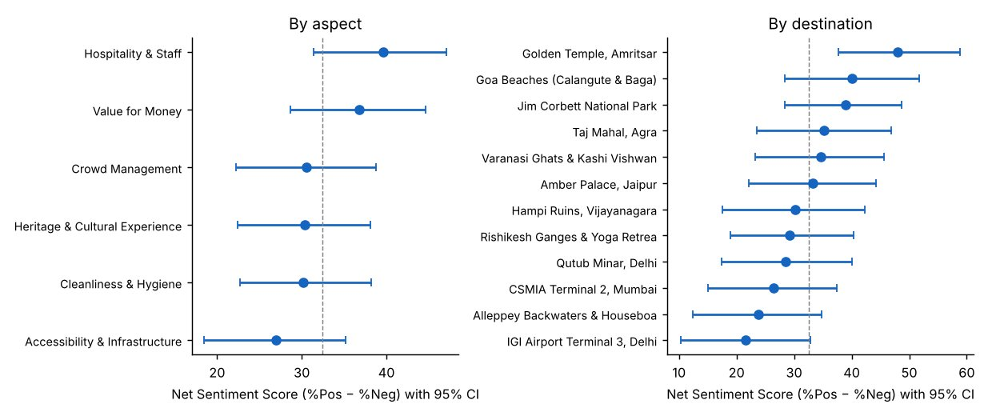
Figure 7. Net Sentiment Score with 95% bootstrap confidence intervals
What it shows. Aspect intervals overlap almost completely (dashed line = mean), so the ranking of aspects is not reliable. Destination intervals separate at the extremes: Golden Temple (+48.0, CI 37.7 to 58.8) is above the intervals of IGI Terminal 3 (+21.6, CI 10.4 to 32.9) and Alleppey (+23.8, CI 12.4 to 34.8).
Test of independence (sentiment × …) | χ² | df | p-value | Reading
Aspect | 12.4 | 10 | 0.262 | No evidence aspects differ
Destination | 35.5 | 22 | 0.035 | Weak; p > 0.0125 after Bonferroni correction for 4 tests
Origin (domestic / international) | 1.4 | 2 | 0.501 | No difference (NSS +33.6 vs +29.7)
Tourist segment (6) | 5.8 | 10 | 0.833 | No difference
Table 2. Chi-square tests on the 2,500 simulated reviews.
By destination category, NSS is Spiritual +37.1, Nature & Leisure +34.4, Heritage +31.7 and Transit & Infrastructure +24.0, the lowest. Quarterly NSS moves between +27.9 (2023Q1) and +36.6 (2024Q1), but all quarterly intervals overlap, so no seasonal or trend claim is made (Figure 8).
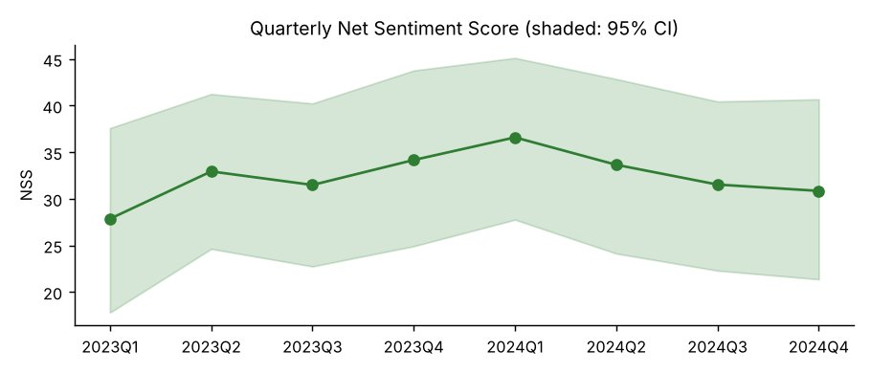
Figure 8. Quarterly Net Sentiment Score
What it shows. NSS fluctuates within a band that the confidence interval fully covers. In real data this chart would be the monitoring view for management; here it shows that the simulated sentiment has no real time trend.

8. What the Evidence Does and Does Not Support
Because the corpus is simulated, conclusions about India's tourism sector cannot be drawn from it. What the analysis does support is a decision method and a set of findings about the tools:
Finding | Strength of evidence
Supervised classifiers beat VADER/TextBlob by 23–27 accuracy points on this data | Strong: non-overlapping CIs, stable across folds and unseen destinations
Neutral and mixed-clause reviews are the hard cases for all methods | Strong: Figures 5–6; VADER Neutral recall 7%
Transit hubs and Alleppey have the lowest sentiment; Golden Temple the highest | Moderate: extreme CIs separate; middle destinations do not
Aspect ranking (Hospitality highest, Accessibility lowest) | Weak: intervals overlap, χ² p = 0.26; do not act on it alone
Domestic vs international, segment, season differences | None found

9. Strategic Recommendations for Tourism Management
Each recommendation is linked to a finding, has a measurable KPI, an owner, a timeline and a stated risk. Figures such as thresholds are illustrative targets calibrated on the simulated data, to be reset once real review data is available. No budget figures are proposed because this analysis cannot support cost estimates.
# | Action | Evidence | KPI and target | Owner / timeline | Main risk
1 | Targeted service audit at the three lowest-scoring sites: IGI Terminal 3, Alleppey, CSMIA Terminal 2 | NSS +21.6, +23.8, +26.5; combined 28.6% Negative (n = 651) vs 24.0% overall; Transit category NSS +24.0 | Cut Negative share from 28.6% to the corpus level (24.0%) within two quarters (illustrative) | Site managers; 3 months | Audit targets symptoms; reviews may reflect factors outside site control
2 | Document and share Golden Temple practices as an internal benchmark | NSS +48.0 with only 15.7% Negative; CI separates from the bottom two | Written playbook; adoption checklist at 2 sites | Regional office; 2 months | Practices may not transfer to a different site type
3 | Track aspects continuously, act only when an aspect's CI excludes the overall NSS | Aspect CIs overlap, χ² p = 0.26 | Alert rule: aspect CI upper bound < overall NSS | Analytics team; ongoing | Small samples per aspect give wide CIs; need ≥ 400 reviews per aspect per period
4 | Treat Neutral and mixed-clause reviews as an early-warning queue | 19.6% Neutral, 659 mixed-clause rows (26%); VADER Neutral recall 7% | Weekly review of mixed reviews; share of mixed reviews that name a fixable issue | Guest-experience team; 1 month | Manual effort; needs sampling
5 | Replace lexicon scoring with a locally trained classifier and keep a human-review queue for low-confidence predictions | +23 accuracy points over VADER; ensemble gives class probabilities | Macro-F1 ≥ 0.80 on 500 manually labelled real reviews before go-live | Data team; 2 months | Performance on real text will be lower than on the simulated corpus
6 | Validate the full pipeline on real reviews (Google Maps / TripAdvisor within their terms of use) | All results here rely on simulated text | Re-run honest_evaluation.py unchanged; report accuracy with CI | Analytics team; 1 month | API and terms-of-use restrictions on scraping

Illustrative impact. If action 1 brought the three lowest sites to the average Negative share, the Negative share across those 651 reviews would fall by about 4.6 percentage points, and the NSS of the group would rise by the same amount (all else equal). This is a target-setting calculation, not a forecast.

10. Limitations and Threats to Validity
- Simulated, templated data. Results show method behaviour on synthetic text. Real reviews contain sarcasm, code-mixing (Hindi/English), typos and emojis that this corpus lacks.
- Labels derived from star ratings and 39 texts carry conflicting labels, so accuracy has a ceiling below 100% and the labels are not independent human judgements.
- Low diversity: 1,244 distinct texts. Grouped splits remove exact duplicates but not near-duplicate templates, which is why scores stay high.
- Negation handling: the NOT_ tag is lost when the next word is a stop-word (Example 2). Fix: apply the tag after stop-word removal or over a window of 2–3 content words.
- Aspect labels are generator metadata, not predicted by a model. A real deployment needs a separate aspect-extraction step (for example keyword seeding or zero-shot classification).
- No transformer baseline and no hyper-parameter search; ensemble weights were fixed a priori.
- Confidence intervals treat the 1,244 texts as independent draws; they do not capture generator-level dependence.

11. Reproducibility
All commands run from the folder Week 5 - Sentiment Analysis. The corrected evaluation reads the cleaned corpus produced by the original preprocessing script and writes every table and figure used in this report.
git clone https://github.com/avy-pixel/Tourism-insights.git
cd "Tourism-insights/Week 5 - Sentiment Analysis"
pip install -r requirements.txt
python -c "import nltk; [nltk.download(p) for p in ['vader_lexicon','wordnet',
'omw-1.4','punkt','stopwords','averaged_perceptron_tagger_eng']]"
python scripts/prepare_reviews_data.py # corpus + preprocessing -> data/
python scripts/honest_evaluation.py # CV, CIs, errors, NSS -> metrics_v2/
python scripts/worked_examples.py # worked examples -> metrics_v2/
python scripts/generate_figures_v2.py # Figures 1-8 -> figures_v2/

File | Content
data/tourist_reviews_raw.csv, tourist_reviews_cleaned.csv | Simulated corpus before and after preprocessing
metrics_v2/benchmark_honest.csv | Table 1 (all models, CIs, unseen-destination scores)
metrics_v2/summary.json | Per-class metrics, confusion matrices, error analysis, chi-square tests, top terms
metrics_v2/nss_by_*.csv | Aspect, destination, segment, origin and quarter tables with CIs
metrics_v2/ensemble_errors.csv, vader_errors.csv | Every misclassified review
metrics_v2/worked_examples.json | Section 4.1 examples with intermediate outputs
figures_v2/ | Figures 1–8 (PNG and JPG)

12. Conclusion
Supervised TF-IDF classifiers recover the sentiment of the simulated reviews with about 96.5% accuracy, far above VADER (73.0%) and TextBlob (69.3%), and this holds under text-grouped splits and on unseen destinations. The models fail on mixed-clause Neutral/Positive sentences, which is also where lexicon tools fail most. Sentiment differs little across aspects, segments and quarters in this corpus, but transit hubs and Alleppey score clearly below Golden Temple, which gives a defensible priority list. The main next step is to run the unchanged pipeline on real, manually labelled reviews, since the simulated text cannot show real-world performance.

